INDEX

REF: 144/ET/MECL/MM/CONT/CGH/04 DATED: 20/06/2026

Sl No | Item | Page No
COVER NO-2
2 | DETAILS FOR NEFT/RTGS (NATIONAL ELECTRONIC FUND TRANSFER/REAL TIME GROSS SYSTEM) | 2
3 | GST DETAILS FOR BIDDERS | 3
4 | SCOPE OF WORK AND CONDITIONS- Annexure-I | 4
5 | Appendix-I | 9
6 | GENERAL TERMS AND CONDITIONS OF CONTRACT-Annexure-II | 15
7 | MECL–Guidelines for Submission of Bank Guarantee by Bidder/ Contractor/Vendor/Supplier | 23
8 | FORMAT OF EMD BANK GUARANTEE-Annexure-III | 24
9 | FORMAT OF SECURITY/PERFORMANCE BANK GUARANTEE - Annexure-IV | 26
10 | Important Instructions to Bank for Operationalization of Paper-Based Bank Guarantees | 28
11 | Undertaking on acceptance of tender terms and conditions | 30
12 | Power of Attorney/Authorization letter (Regarding authority for submission of bid) | 31
13 | Declaration that bidder is not on holiday list/Delisted/ blacklisted/debarred in PSUs or any Govt. Department/organization | 32
14 | Regarding declaration as per Annexure-B | 33
15 | Make in India Certificate | 34
16 | Declaration for Registration and Compliance with TReDS Platform and Payment provisions for MSME Bidder | 35
17 | Declaration for Statutory Compliance by Vendor / Contractor | 36
18 | Undertaking / Indemnity Certificate | 37
19 | Car Availability Details | 38

COVER NO: 2
MINERAL EXPLORATION AND CONSULTANCY LIMITED
(A GOVERNMENT OF INDIA ENTERPRISE)
TENDER NO | 141/ET/MECL/MM/CONT/CGH/03 | DATED: | 20/06/2026

DETAILS FOR NEFT/RTGS (NATIONAL ELECTRONIC FUND TRANSFER/REAL TIME GROSS SYSTEM)

1 | Name of the Beneficiary | AORVIS Dynamic Pvt. Ltd.
2 | Address (With Pin Code) | A/1. Science Complex, Assam Science Convention Centre, Khanapara, Guwahati, Assam-781022, India

BANK PARTICULARS

1 | Name of Bank | Punjab National Bank
2 | Bank Telephone No. (With STD Code) | 0361-2457847
3 | Branch Name | Bhangagarh
4 | Bank Branch Code | 465100
5 | Bank Address (With Pin Code) | Bhangagarh G. S. Road, Guwahati-781005, Assam, India
6 | Bank Fax No. (With STD Code) | 18001802222
7 | 9 Digit MICR Code of Bank Branch | 781024007
8 | 11 Digit IFSC Code of Beneficiary Bank | PUNB0465100
9 | Bank Account No. | 4651002100007974
10 | Type of Account | Current Account
11 | Permanent Account Number (PAN) | ABACA0356M
12 | Email for intimation regarding release of payment | care@pnb.co.in

I hereby declare that the particulars given above are correct and complete. If any transaction is delayed or not effected for reasons of incomplete or incorrect information, I shall not hold MECL responsible. I also undertake to advise any change in the particulars of our account to facilitate updating of records for purpose of credit of amount through RBI EFT/Internet/RTGS.

DATE: 30/06/2026
COVER NO: 2
MINERAL EXPLORATION AND CONSULTANCY LIMITED
(A GOVERNMENT OF INDIA ENTERPRISE)
TENDER NO | 141/ET/MECL/MM/CONT/CGH/03 | DATED: | 20/06/2026

GST DETAILS FOR BIDDERS IF APPLICABLE

1 | Name | AORVIS Dynamic Pvt. Ltd.
2 | Address (As per registration with GST) | A/1, Science Complex, Assam Science Convention Centre, Khanapara, Guwahati, Assam-781022
3 | City | Guwahati
4 | Postal Code | 781022
5 | Region/ State (Complete State Name) | Assam
6 | PAN Number | ABACA0356M
7 | GST ARN No. (Acknowledgement Attached): | `NA
8 | GSTIN Provisional ID No. (Acknowledgement Attached) | NA
9 | Type of Business (As per Registration with GST) | Information Technology, Consulting and Support Services and Handling of Geophysical Equipment
10 | Contact Person | Reepjyoti Deka
11 | Phone Number | 8135866886
12 | Mobile Number | same
13 | Email ID | Aorvis.india@gmail.com
14 | Service Accounting Code/HSN Code | 998313, 842810

DATE: 30/06/2026

COVER NO: 2
ANNEXURE-I
MINERAL EXPLORATION AND CONSULTANCY LIMITED
(A GOVERNMENT OF INDIA ENTERPRISE)
TENDER NO | 141/ET/MECL/MM/CONT/CGH/03 | DATED: | 20/06/2026

SCOPE OF WORK AND CONDITIONS

Rate Contract for Geophysical Equipment Handling Services (Ground Gravity and Magnetic survey under NGPM)

Rate Contract: Hiring of Services for Handling Geophysical Equipment during Ground Gravity and Magnetic Survey Work for Geological Survey of India under NGPM.
1. Introduction:
Mineral Exploration and Consultancy Limited (MECL) invites Rate Contracts from interested contractors/agencies for providing geophysical equipment handling services in support of surface geophysical (Ground gravity, magnetic & DGPS) survey work in various regions of GSI. The photographs of various Geophysical equipment are given in Appendix‑1 to give an idea to participating parties about the size of equipment / nature of work.
This work in 34 toposheets (8221 stations) falling in the state of Uttar Pradesh under NGPM work (Phase 4 – GSI‑ER) is likely start in the end of January 26.

It is proposed to deploy 4 teams initially and may increase / decrease depending upon the availability of resources. The contractor shall quote charges on per station basis for each team.
The services shall comprise shifting, transportation, and handling of geophysical equipment. Details of services required from contractor are provided in the Scope of Work section. This tender is for rate contract only. Work Order shall be issued separately under the Rate Contract, specifying the quantum of work, timelines, and other relevant details ,3 weeks before the commencement of work.
Bids are invited from interested contractors/agencies meeting the eligibility and qualification criteria specified in this document. All bids must be submitted in the prescribed format within the stipulated timeline, including all required supporting documents. Non‑compliance with the submission requirements may result in disqualification. The contractor shall quote charges on per station basis considering the resources required to achieve the expected productivity. The L1 bid will be considered.
2. Scope of Work
The contractor shall provide geophysical equipment handling services in support of surface geophysical (Ground gravity, magnetic & DGPS) survey work. The details are as below:
Region | No of toposheets | No of Observations (Stations) | Time line | Remarks
GSI‑ER: | 30 (Odisha) | 6484 (Approximately) | 7.5 months | 5-10% stations to be repeated for validation without any charges
Initially 4 teams may be deployed and may increase / decrease depending upon the availability of resources.
The service provider shall be responsible for the following per each team:
- Providing one vehicle of Bolero or similar class (4 x4) vehicle (closed body) with taxi permit (transport category). Note: Vehicle should be in good condition (not more than 10 years old) with all valid documents (insurance, PUC, fitness, tax certificate etc.).
- Transportation of equipment from MECL Nagpur office (or any other block as specified later) to the designated camp office during commencement of work and return to MECL Nagpur office (or any other block as specified later) after completion of work.
- Necessary permits from RTO shall be obtained by the service provider on his own cost.
- Ensure the daily transportation of equipment between the camp office and field sites.
- All the expenditure incurred in repairs and maintenance of vehicles / resources provided shall be borne by the Service Provider.
- Cost of fuel, lubricating oil or any other consumables shall also be borne by the contractor for utilization of all vehicles for carrying out field survey work with an expected running of approximately 3,500 km per vehicle per month.
- Providing required resources for handling equipment to carryout geophysical surveys in remote areas as per requirement
- Undertake loading, unloading, safe handling, and transportation of sensitive instruments and accessories.
- Carrying pegging and shifting of benchmarks between the observed points during course of survey work.
- Preparation of observation points, including clearing of ground, marking on the ground (pegs, paint) and leveling, as required.
- Provide support to the geophysical survey teams in the execution of field operations as instructed by the Officer‑in‑Charge (OIC), MECL.
- Return of equipment to camp locations and safe keeping of equipment on a daily basis.
- Ensure availability of vehicle in good condition for all the days during the contract. The contractor shall provide alternate vehicle in case of any major breakdown.
- General working hours of survey will be between 6 am to 6 pm.
- Perform any other activity necessary for the smooth execution of the survey as may be directed by the Officer‑in‑Charge (OIC), MECL.
3. Productivity & Resource Requirements For Each Team
The details of expected productivity, logistics and resources required—namely, the number of vehicles, POL (HSD for vehicles), and miscellaneous consumables (such as paint, pegs, and drinking water)—per team are provided in the table below.
Survey Description | Logistics / Resources Required | Expected Productivity Per Month per Team | Unit
Gravity, Magnetic & DGPS Survey | No. of Vehicles: 1HSD / POL: Yes  Consumables: Yes | 250 | Station
Note 1: It is proposed to deploy 4 teams initially and may likely to increase / decrease and deploy anywhere in India, if needed by MECL.
Note 2: Approximately 8221 stations are to be covered. Further, 10% stations are to be repeated without any additional charges. The duration of this work is 10 months.
Note 3: The Contractor shall gather necessary information and assess actual requirements before quoting the rates.
Note 4: The contractor shall quote charges on per station basis considering the resources required to achieve the expected productivity per month per team. The L1 bid will be considered.

4. Eligibility Criteria / Documents to be Submitted
- The service provider should be eligible to hire out vehicle as per the RTO norms. It is the sole responsibility of the service provider to obtain necessary permission / certificate if any from RTO or other Transport Office. Bidder should submit list of vehicles along with copies of RCs. The bidder has to provide agreement with the vehicle owner in case the owner of the vehicle is other than the bidder.
- Bidder should have work experience of following :
  - Single work (services to any geophysical work / man power supply work / vehicle supply work) not less than 51.48 lakhs during last three years from the date of tender.

OR
  - Two works (services to any geophysical work / man power supply work / vehicle supply work) each valuing not less than 32.17 lakhs during last three years from the date of tender.

OR
  - Three works (services to any geophysical work / man power supply work / vehicle supply work) each valuing not less than 25.74 lakhs during last three years from the date of tender.
Documentary proof in this regard have (Work Order / Completion certificate to be submitted)

- Company profile, documentary proof of PF Establishment code, ESI registration certificate, Bank details, PAN details and GST.

- Financial details demonstrating capacity:
- Solvency certificate from a nationalized/scheduled bank for an amount of ₹50 lakhs issued within the last 6 months from date of tender.

- The bidder shall provide an undertaking certificate stating the following: The bidder shall indemnify, defend, and hold harmless the Employer, its officers, employees, and agents from and against any and all losses, damages, liabilities, claims, actions and costs arising out of or in connection with:
- Any breach of this contract by the bidder;
- Any negligence, fraud, or misconduct of the bidder, its employees, agents, or subcontractors;

5. Important Terms and Conditions
- This contract shall work only as rate contract based on rates per unit of work (i.e. per station). Separate work orders under this rate contract will be issued at the time of commencing work, specifying the actual quantum of work, location(s), and timeline.
- The optimum productivity per team shall be achieved for each month, as specified in the table above. In case of shortfall in any month, the target productivity of succeeding month will be the total of optimum productivity and shortfall in the previous month. Ten percent (10%) stations to be repeated for validation without any charges. The contractor shall ensure services to achieve the total awarded work within the timeline given in the work order.

6. Special Instructions to Bidders
- Bidders are advised to carefully study the Scope of Work and familiarize themselves with site conditions, working hours, nature of work, type of survey, and resources required to execute the work prior to submitting the tender.
- Any clarification, if required, must be sought before submission of bids.
- Incomplete or conditional bids are liable to be rejected.
- This tender is for a rate contract only; the rates quoted shall remain valid for a period of one year from the date of award. The contract may be extended for a further period of one year on the same terms and conditions, at the sole discretion of MECL, subject to satisfactory performance.
- The Contractor shall quote charges on a per-station basis for this survey. Such quoted rates shall be deemed to include, but not be limited to, all resources, consumables, and logistics necessary for execution of the work. This shall specifically cover the provision of vehicles (Bolero or equivalent), cost of High-Speed Diesel (HSD) for vehicle operations (i.e. running of 3500 km per month), and all other incidental expenses essential to achieve the specified productivity per team.

7. Liability and Risk
- The Contractor shall be solely responsible for the safety of its resources, vehicles, and property deployed for execution of the work under this contract.
- All risks, including but not limited to loss, damage, accident, injury, or any other liability arising during the performance of the work, shall rest entirely with the Contractor until successful completion and acceptance of the work by MECL.
- MECL shall not be held liable for any loss or damage to the Contractor’s resources, vehicles, or property, howsoever caused, during the execution of the work.
- The Contractor shall, at its own cost, take all necessary precautions, safety measures, and insurance cover as required under applicable laws and good industry practices to safeguard against any such risks.

8. Responsibilities of the Contractor
The Contractor shall:
- Maintain vehicle running log books and bear all costs related to POL (fuel, etc.), road taxes, maintenance, and insurance of the vehicles/resources deployed under this Contract. (Note: Toll charges and parking charges will be paid, if required, by OIC, MECL.)
- Be responsible for the proper execution of the assigned work and safe upkeep of all equipment during the execution of this contract in order to achieve the optimum productivity as specified in the table above.
- Be solely responsible for the health, safety, and wellbeing of all engaged resources for executing this contract.
- Ensure compliance with all applicable statutory provisions, regulations, and standards relevant to the execution of the work on a monthly basis, and submit an undertaking confirming such compliance along with the invoice.
- Be responsible for any loss or damage caused to the equipment, instruments, or vehicles due to negligence, mishandling, or unsafe practices.

9. Payment Terms & Bank Guarantee
- Performance Bank Guarantee: The successful bidder shall be required to furnish a Performance Bank Guarantee equivalent to three percent (3%) of the individual work order value, in accordance with the terms and conditions of the tender. Any conditional offer regarding Bank Guarantee (BG) terms shall not be accepted at any stage of the tendering process, including bid submission, post-bid submission, price bid opening, offer acceptance, and work execution.
The Performance Bank Guarantee shall be issued in the form of Insurance Surety Bonds, Account Payee Demand Draft, or Bank Guarantee (including e-Bank Guarantee) from a Scheduled Commercial Bank (except Cooperative Bank & Gramin Bank) in India on a non-judicial stamp paper of appropriate value as per applicable state law.
The Performance Bank Guarantee in the form of Insurance Surety Bonds / BG shall be valid for one (1) year (claim period) beyond the date of completion of all contractual obligations including warranty obligations.
In case of any extension of the contract obligation period, the service provider shall be liable to suitably extend the validity of the performance security.
Note:
a. Wherever a Performance Bank Guarantee (PBG) is applicable, the option of submitting a Fixed Deposit Receipt (FDR) is not acceptable.
b. Bank Guarantee for EMD and Security/Performance Bank Guarantee submitted as per the prescribed format shall only be accepted.
- Processing of payment will be taken up only upon submission of an undertaking by the service provider, along with the invoice, confirming compliance with all statutory requirements for the work executed during the preceding month.
- Payment shall be made on a monthly basis, against the invoice submitted by the service provider based upon the quantum of work (number of stations) completed during the month and certified by the Officer-in-Charge (OIC), MECL, as per the issued work order.
- In the event when the distance travelled exceeds the monthly usage (3500 km per vehicle), the cost of HSD @ 1 liter per 10 km run (i.e. average of 10 km per liter is considered) will be reimbursed by MECL.
- Statutory deductions, as per prevailing laws and norms, shall be applicable.

10. Contact Details
For further clarification, please contact:
Name: K. S. R. K. S. Sai
Designation: DGM (Geophysics)
Email: kksrksai@mecl.co.in
Phone: +91 9829127182

GM / HOD (Procurement and Contract)

Appendix–I

Photographs Showing GEOPHYSICAL Equipment

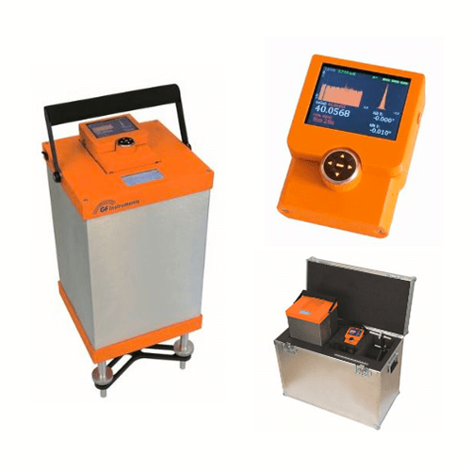
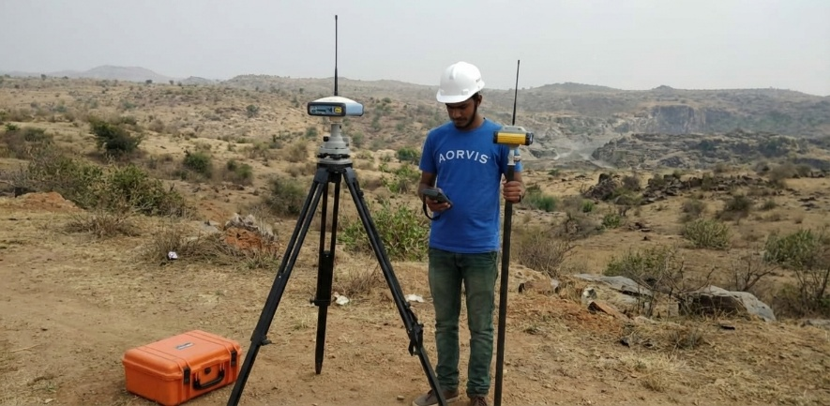
Gravimeter & DGPS
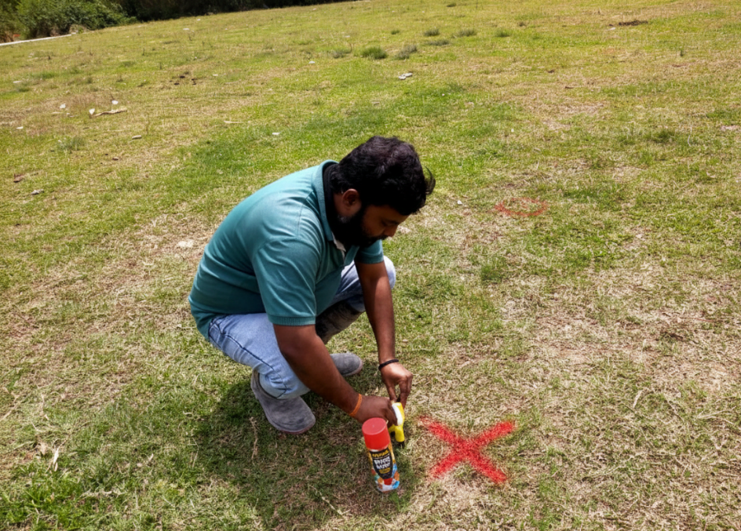
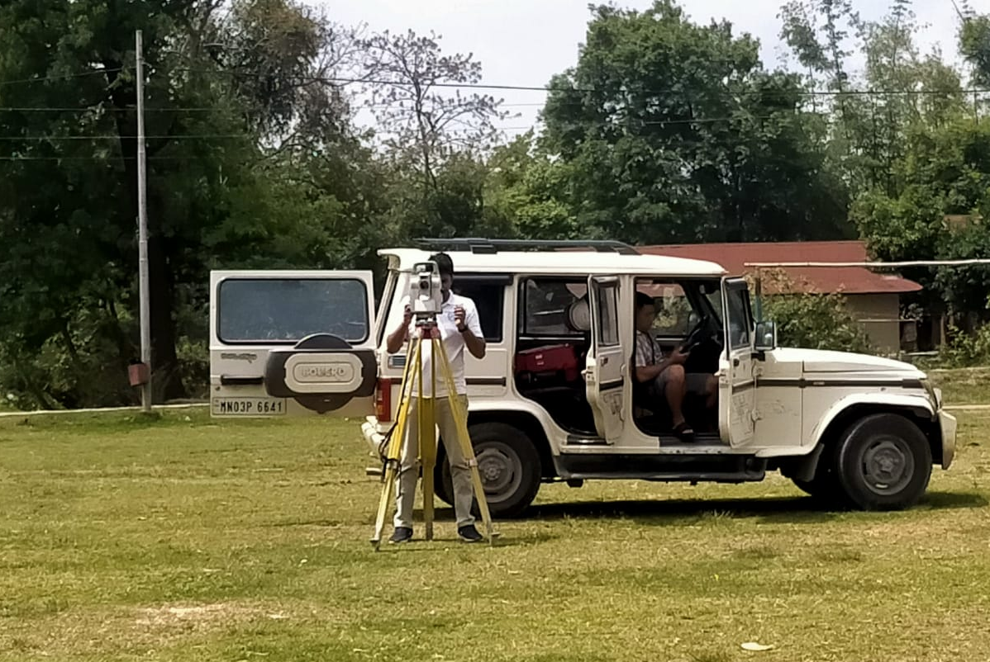
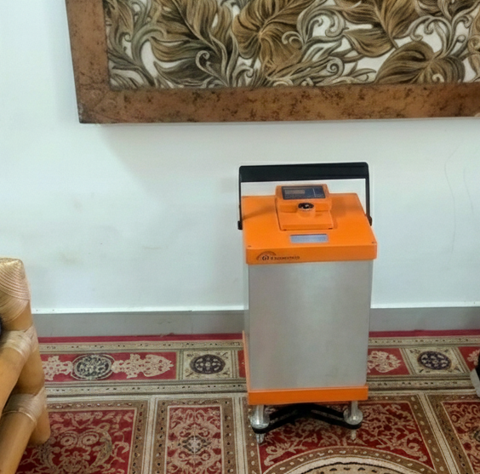
Magnetometer
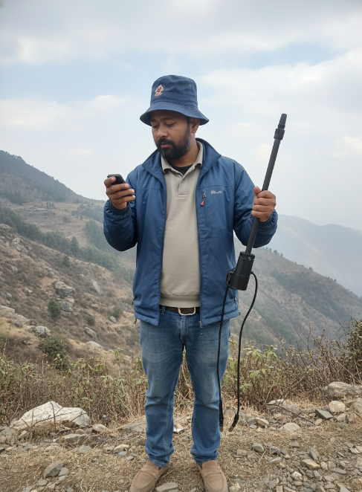
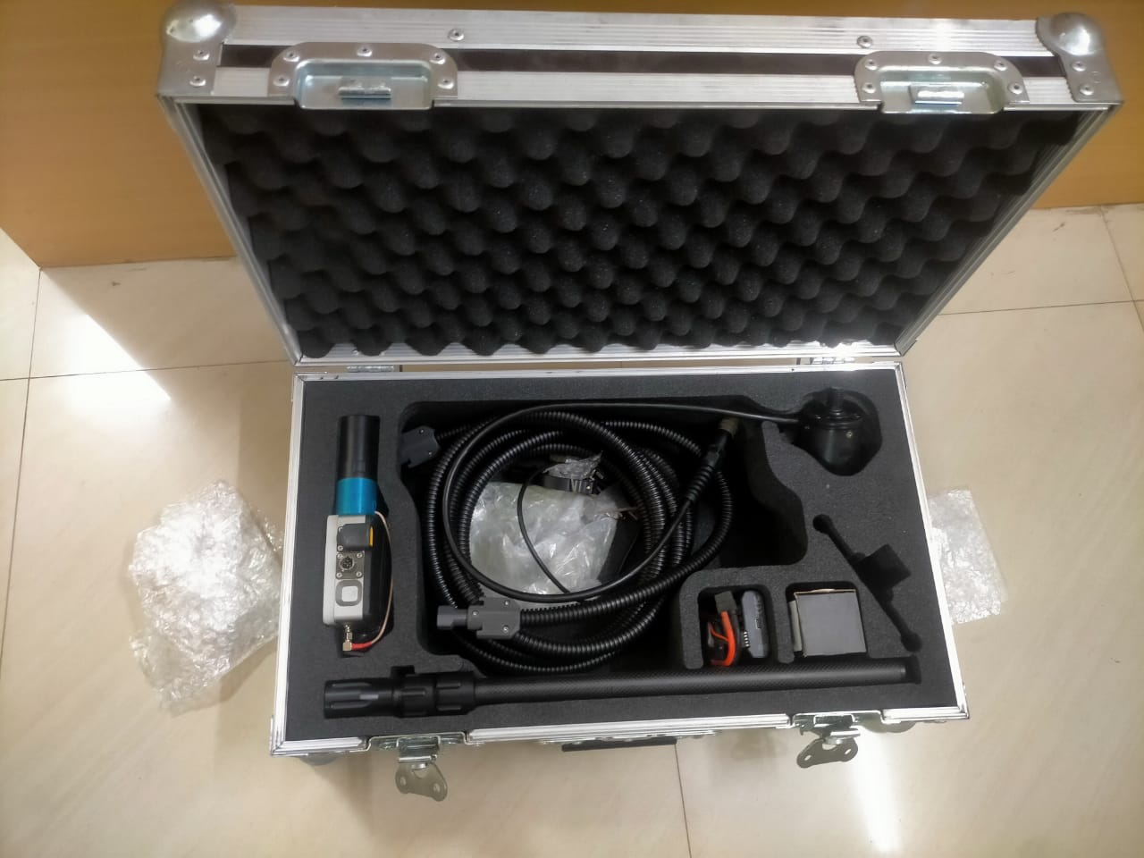
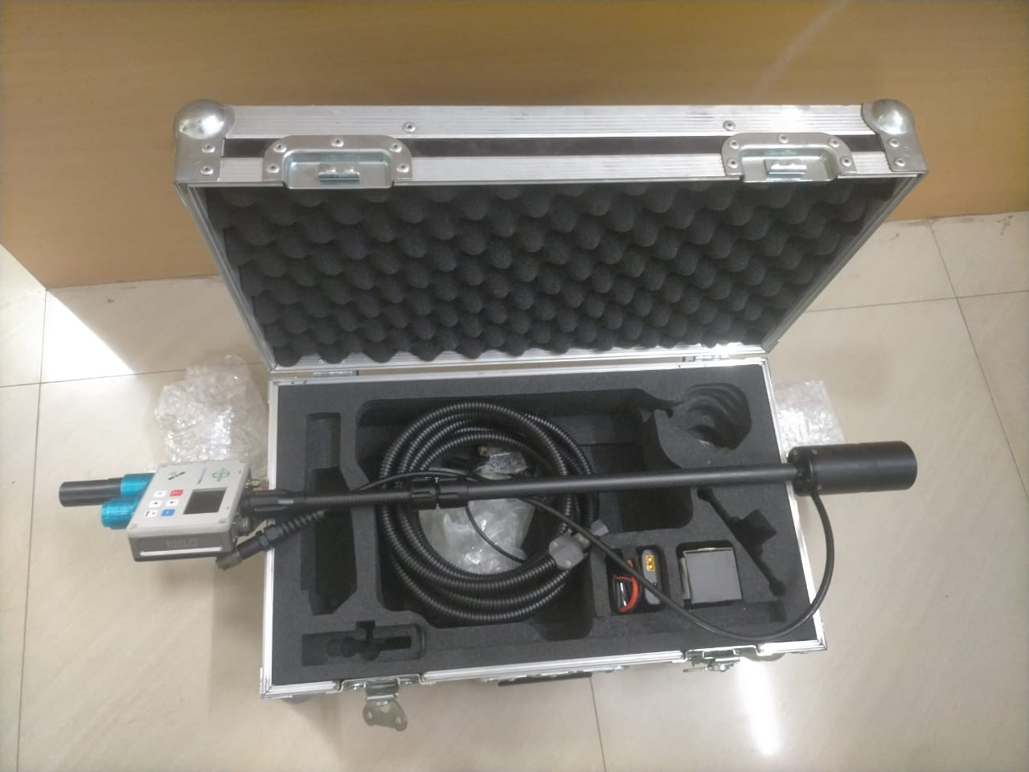
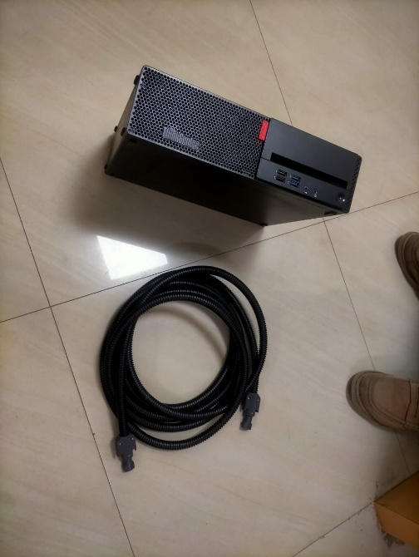
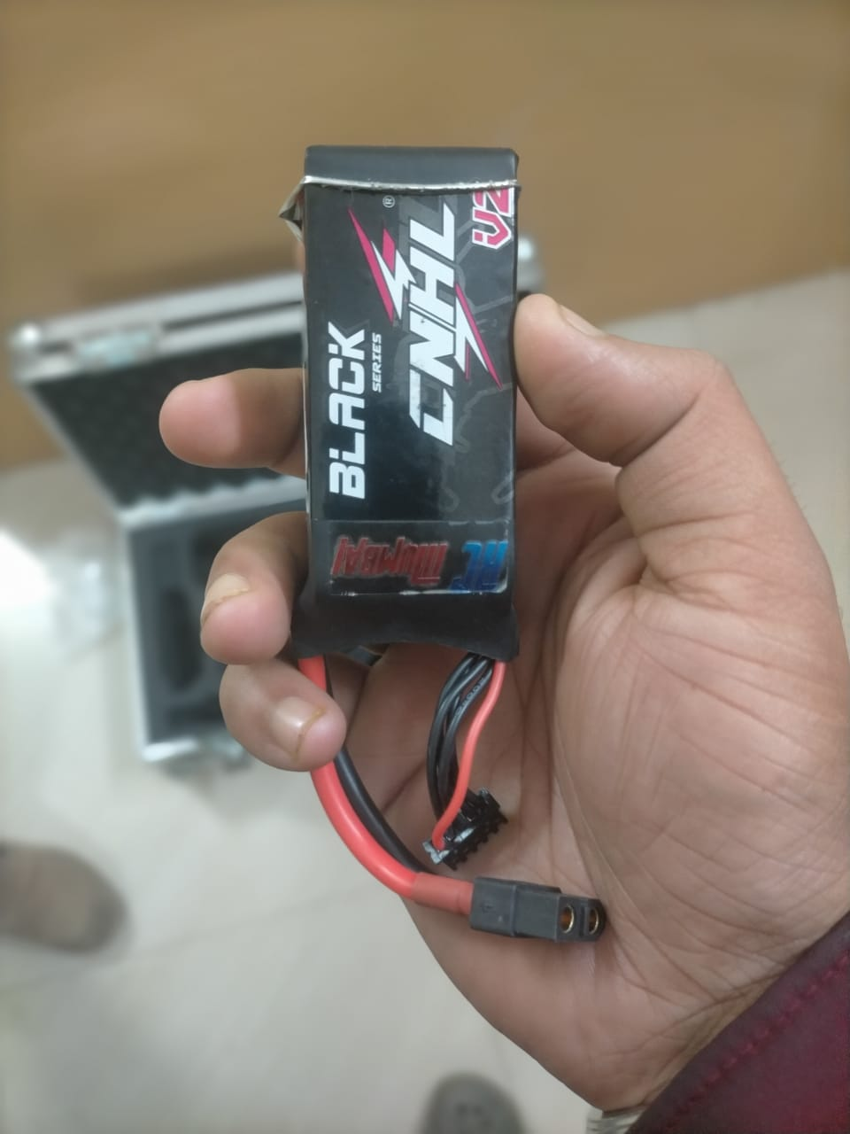
EM, TEM Equipment
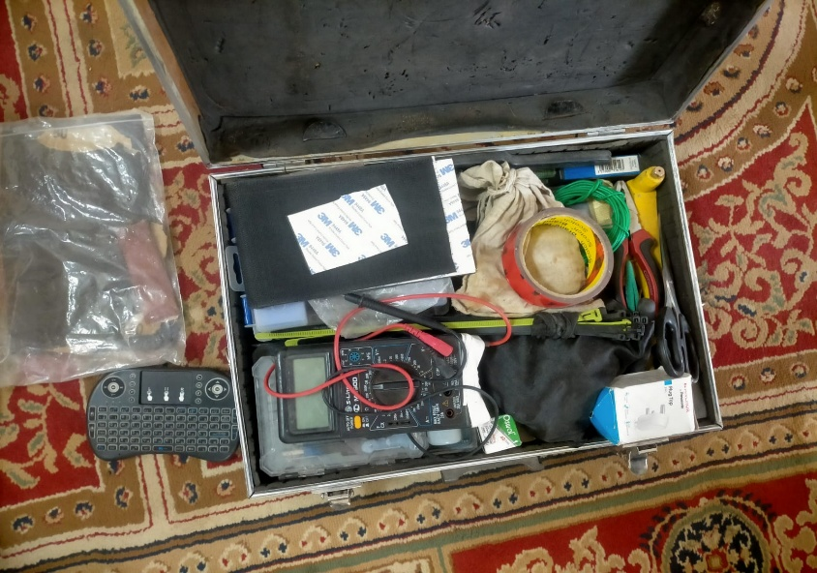
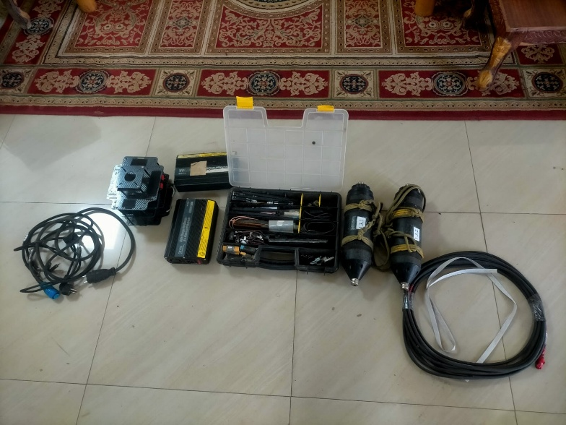
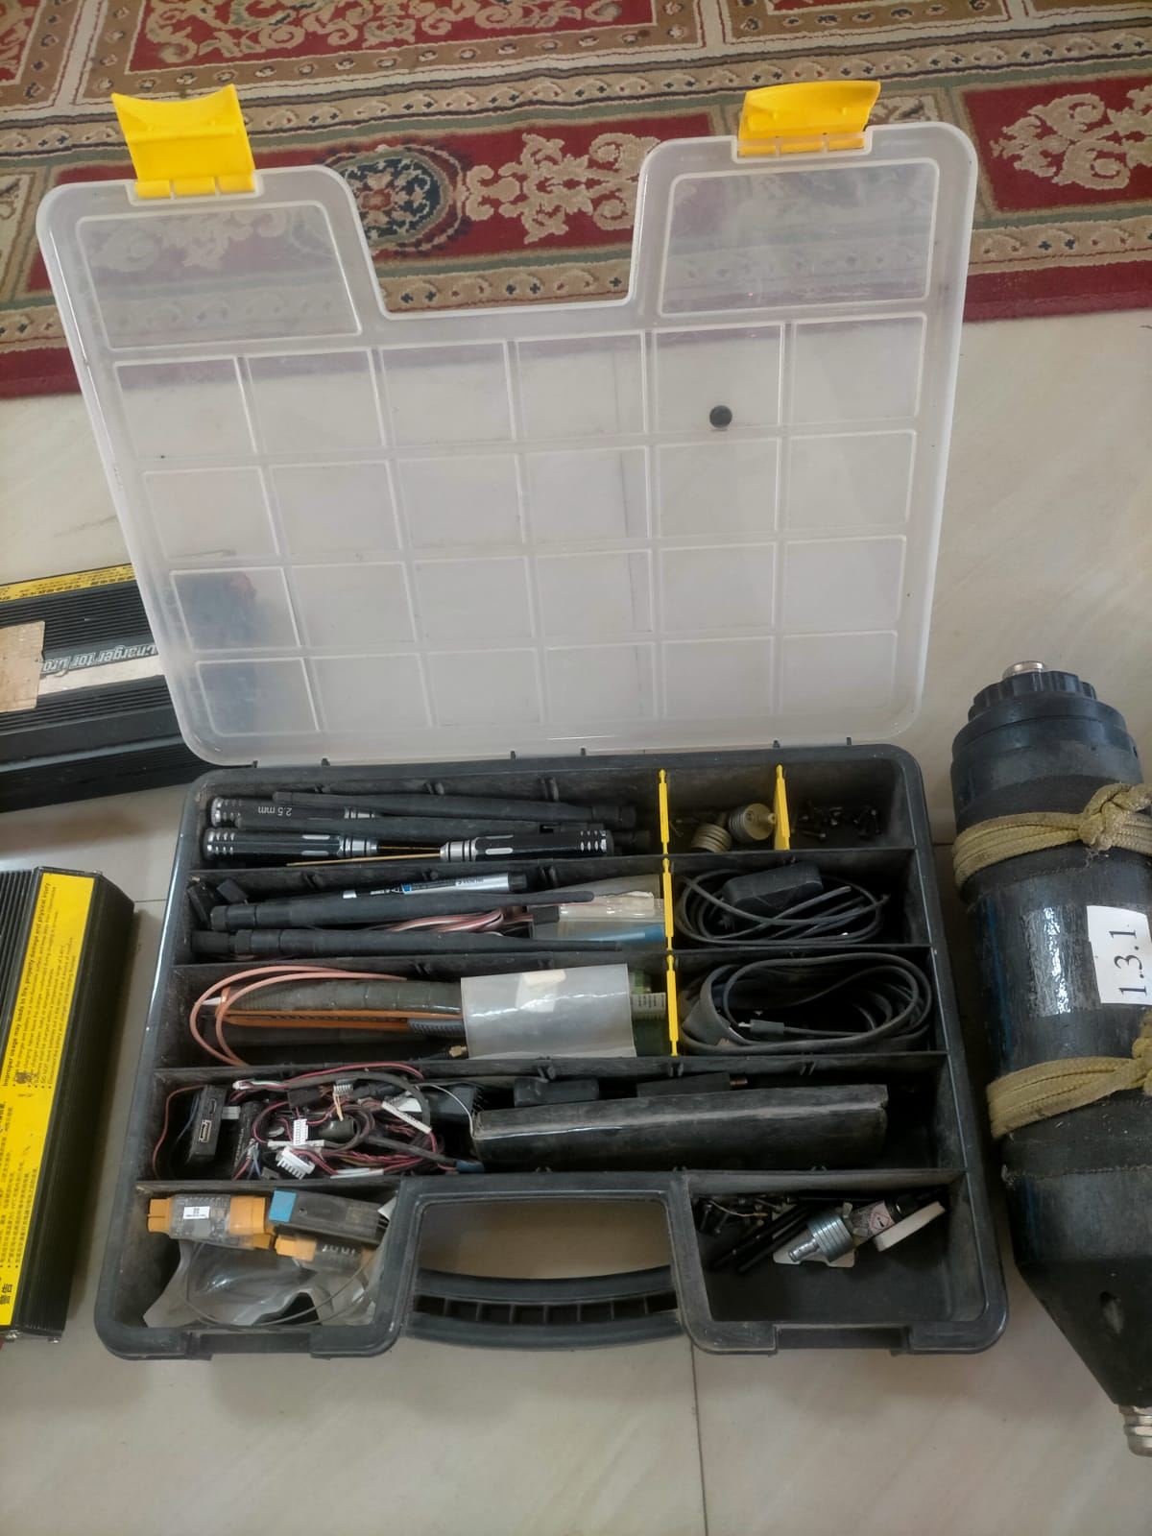
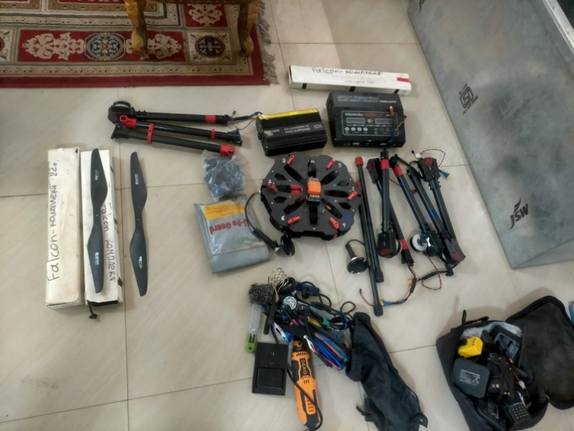
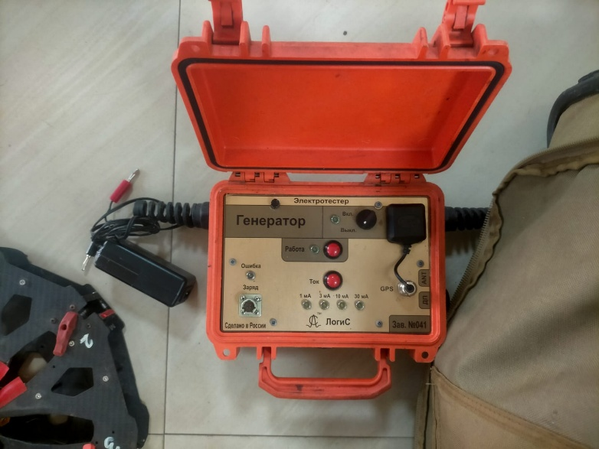

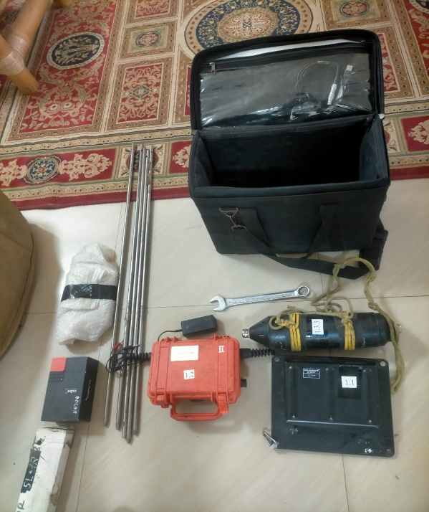
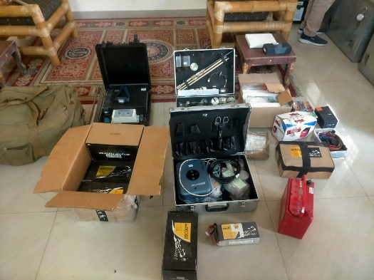
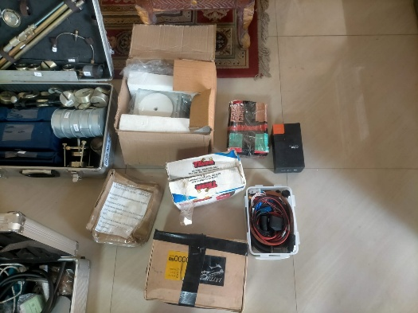
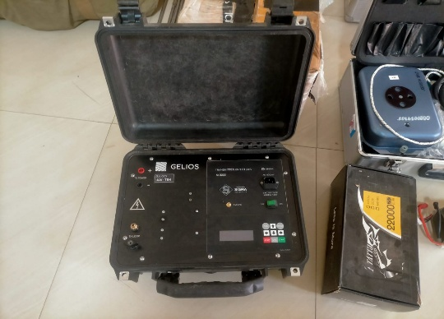
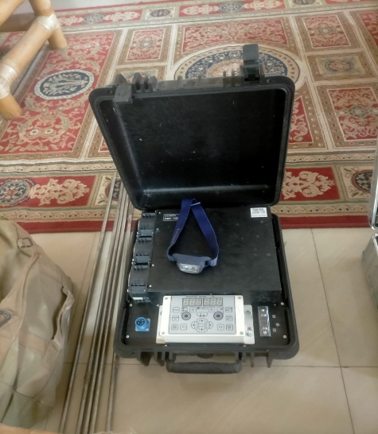
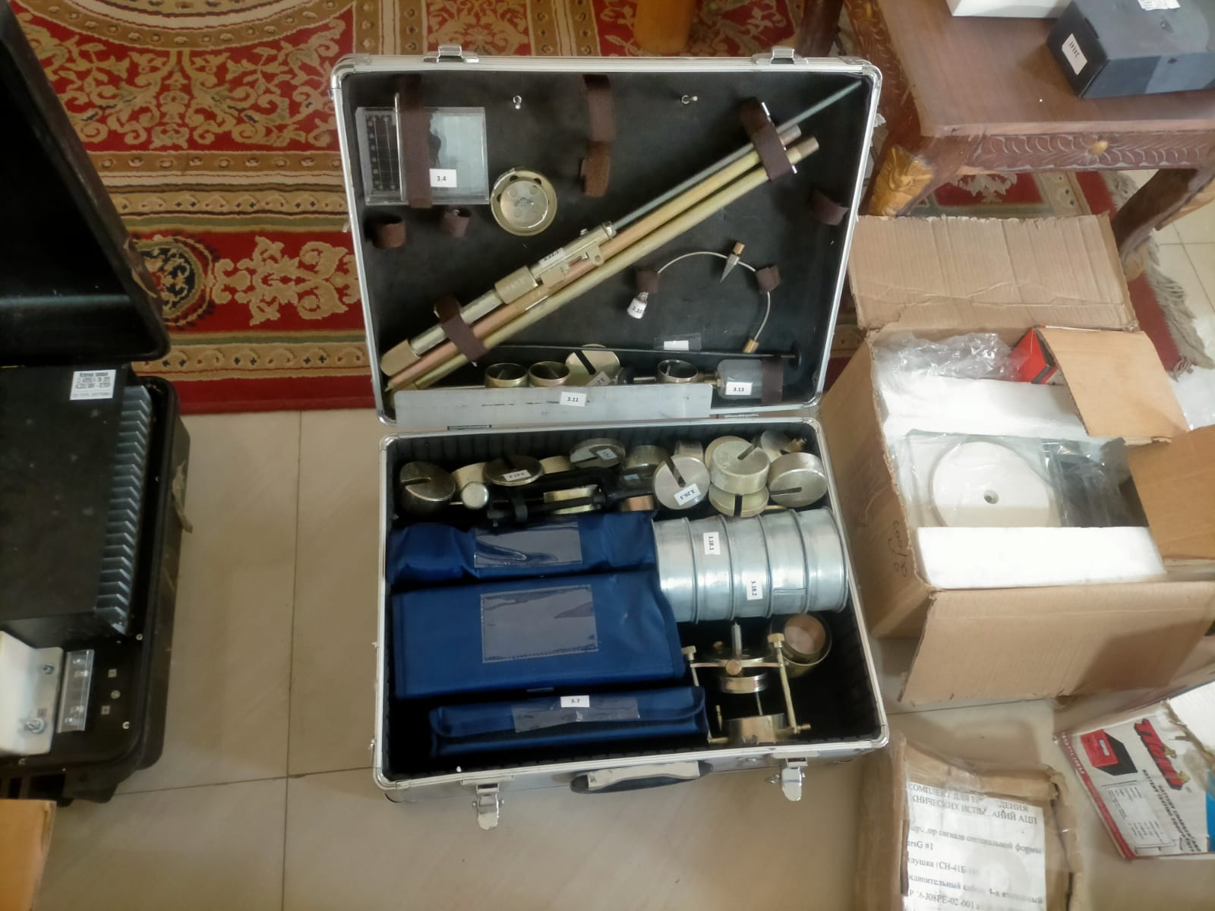
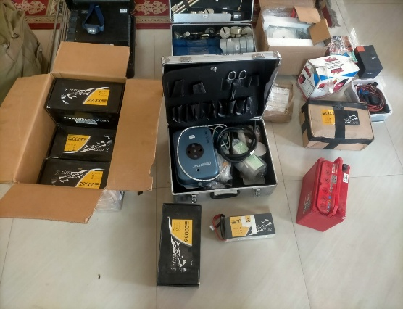
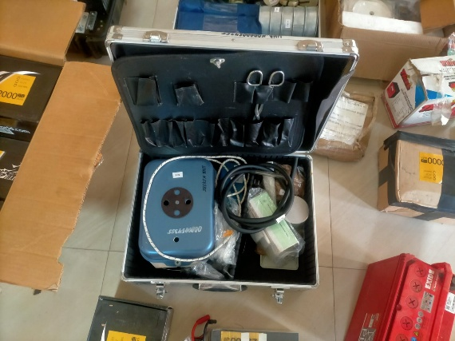
EM, TEM Equipment
Geophysical Survey Works by AORVIS
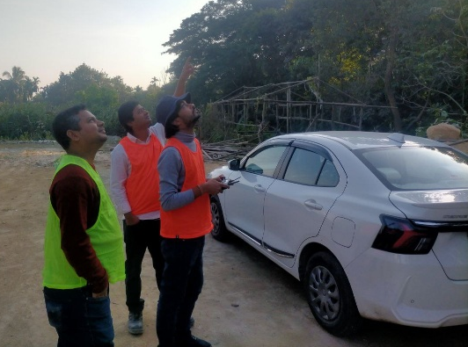
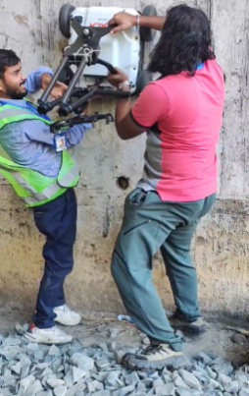

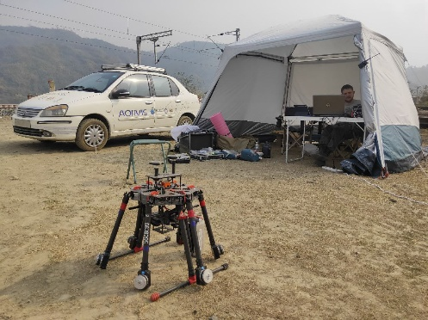
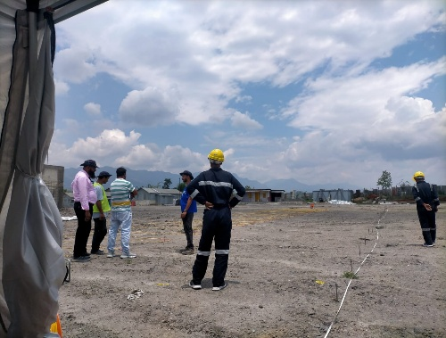
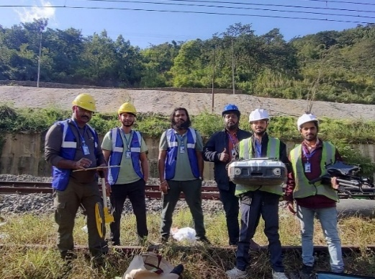
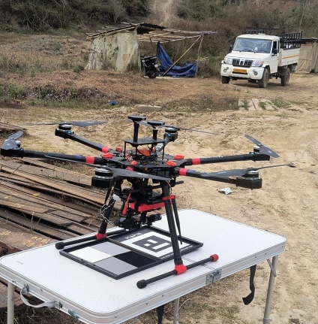
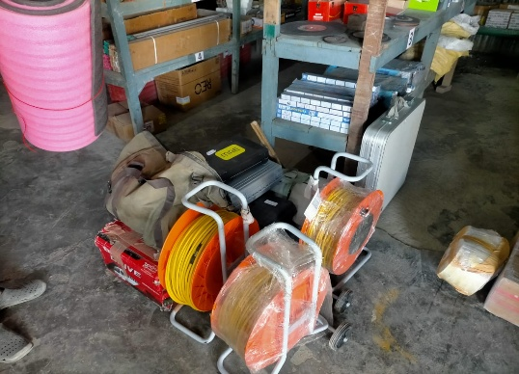
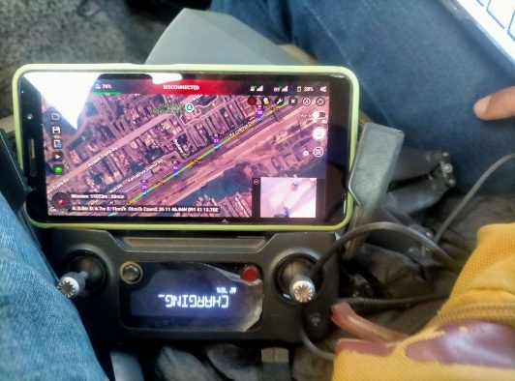
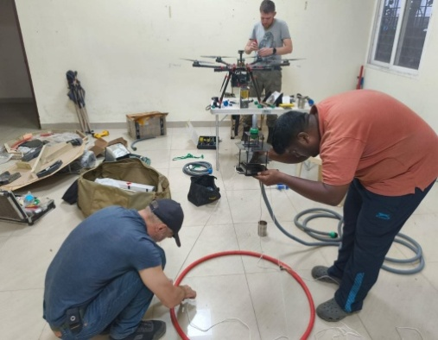
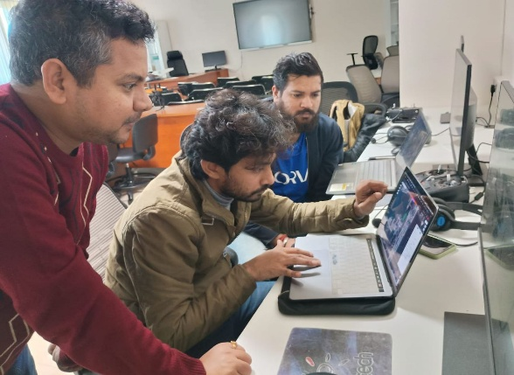
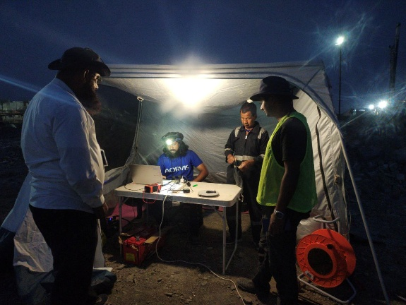
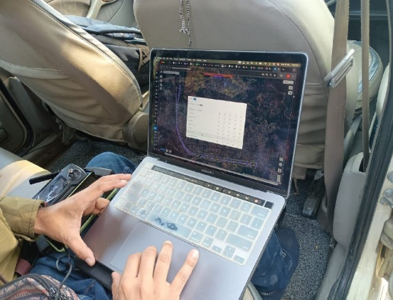
COVER NO.: 2

ANNEXURE–II
MINERAL EXPLORATION AND CONSULTANCY LIMITED
(Formerly Mineral Exploration Corporation Ltd.)
(A GOVERNMENT OF INDIA ENTERPRISE)

TENDER NO | 141/ET/MECL/MM/CONT/CGH/03 | DATED: | 20/06/2026

GENERAL TERMS AND CONDITIONS OF CONTRACT

1) DEFINITIONS:
a) “MECL/Company/Owner” shall mean Mineral Exploration and Consultancy Limited, A Government of India Enterprise having registered office at Dr. Babasaheb Ambedkar Bhavan, High Land Drive Road, Seminary Hills, Nagpur, including its successors and assignees or its authorized representatives. Company shall also mean the Owner wherever the context requires.
b) “Tenderer/Bidder” shall mean the Person/Firm/Co-operative/Party/Company whether incorporated or not who submits the tender for the works with a view to execute the works on contract with the MECL and shall include their personal representatives, successors and permitted assignees.
c) “Contractor” shall mean the successful Tenderer/Bidder or the Person/Firm/Co-operative/Party/Company whether incorporated or not who enters into the contract with MECL to execute the works and shall include their executors, administrators, successors and permitted assignees.
d) “Works” shall mean the works to be executed in accordance with the contract.
e) “Contract” shall mean and include the Agreement of Work Order if any, the accepted Schedule of Rates, the General Terms & Conditions of the contract, the Special Terms & Conditions of the contract and the Specifications, the Tender Forms, if any.
f) “Site” shall mean the lands and other places on, under, in or through which the works are to be carried out and any other lands or places provided by the company for the purpose of the contract.

2) Assignment and Sub-letting:
The Contractor shall not assign or sub-let the Contract or any part thereof, or any benefit or interest therein or thereunder, without the prior written consent of the Mineral Exploration and Consultancy Limited. However, these provisions do not bar Insurance Company from taking reinsurance cover on the policy.
3) General Obligations: Contractor’s General Responsibilities
a) The Contractor shall, subject to the provisions of the Contract, and with due care and diligence, execute and maintain the works and provide experienced manpower having sound knowledge of tendered work.
b) The contractor shall maintain the full confidentiality of all the information/data/reports etc. as provided by the company (MECL), both in oral and written form as well as those of the Documents/Reports of the proposed work under the contract. And nothing will be communicated to the Third party without the written consent of the client failing which contract is likely to be terminated and security deposit shall be forfeited.

4) Work to be Executed to the Satisfaction of MECL:
The Contractor shall execute and maintain the work in strict accordance with the Contract to the satisfaction of MECL representative and shall comply with and adhere strictly to MECL’s instructions and directions on any matter whether mentioned in the Contract or not, touching or concerning the works. In case the company is not satisfied with the performance of the Contractor in terms of the quality and quantity the company reserves the right to terminate the contract without assigning any reason and without giving any notice. Contractor will have no claim of compensation whatsoever.

5) Damage to Persons and Property:
The Contractor shall indemnify MECL against all losses and claims in respect of injuries or damage to any person or material or physical damage to any property whatsoever which may arise out of or in consequence of the execution and maintenance of the works and against all claims, proceedings, damages, costs, charges and expenses whatsoever in respect of or in relation thereto.

6) Engagement of Labour & Staff:
The Contractor shall make his own arrangements for the engagement of all labour and staff, local or otherwise provides, for the transport, housing, feeding and payment thereof and no claim for medical aid to engage persons or any incidental charges will be entertained.
The contractor shall at all times take all reasonable precautions to prevent any unlawful, riotous or disorderly conduct by or amongst his employees and for the preservation of peace and protection of persons and property in the neighbourhood of the works against the same.

7) Compliance with Statutes, Regulations, etc:
The Contractor shall conform in all respects with the provisions of any statute, Ordinance or Law as aforesaid and the regulations or bylaws of any local or other duly constituted authority which may be applicable to the works and shall ensure and regulations of public bodies and companies as aforesaid, and shall keep MECL indemnified against all penalties and liability of every kind for breach of any such Statute, Ordinance or Law, regulation or by law.

8) Commencement of Works:
The Contractor shall make available necessary resources for commencement of the awarded work at the work site within the stipulated time period in the letter of award (LOA)/ Work Order (WO).

9) Time for Completion:
- Subject to any requirement in the Contract as to complete any section of the contract before completion of the work, the whole of the contract shall be completed within the period as specified in the scope of contract.
- If the contractor without reasonable cause, commits default in commencing the execution of the contract within the time stipulated in tender document, MECL shall without prejudice to any other right or remedy, be at liberty, by giving 15 days notice in writing to the contractor to commence the contract, failing which to forfeit the Earnest Money Deposit.
- If, MECL is not satisfied that the contract can be completed by the contractor and in the event of failure on the part of the contractor to complete contract within further extension of time allowed as before said, shall be entitled without prejudice to any other right or remedy available in that behalf to rescind the contract.

10) Rate of Progress:
Performance of the contractor will be judged as per the stipulated conditions in the Tender/ Work Order. For any conditions beyond control of contractor or Force measure Contractor shall be provided extension of time, as per Tender/ Work order’s conditions. If the rate of progress of the assigned work(s) or any section/ part of the work, lagging behind the time schedule as notified for the activities, then MECL shall notify the contractor in writing and Contractor shall thereupon required to take immediate steps for the improvement of the work in progress as prescribed.

11) Risk Purchase:
In the event of failure of the supplier to deliver or dispatch the stores within the stipulated date / period of the supply order or in the event of breach of any of the terms and conditions mentioned in the supply order / contract, MECL shall have the right to purchase the stores from elsewhere after due notice to the defaulting supplier at his risk and cost of the defaulting supplier. In the event of failure of the supplier as detailed above, the cost as per risk purchase exercise may be recovered from the Security Deposit / Performance Security of the supplier and / or bills submitted by the supplier against the same contract or any other contract pending in MECL or either through legal route or through DD/NEFT given by firm. In case successful bidder do not execute the contract, MECL reserves the right to impose risk purchase and also to recover the cost due to loss of revenue for operation stoppage/work stoppage/stoppage of supply of item/Goods. Further MECL reserves the right to debar the bidder for the period of one year from the actual date of debarring letter.

12) Liquidated Damages/ Penalty for Delay:
a) If the contractor fails to achieve progress or fails to complete the work as per schedule of work order, the contractor shall pay Liquidated Damages as specified in the tender work order.
Any delay on part of MECL to provide adequate technical support, which is beyond the control of the contractor shall be jointly recorded and certified by the Project Manager/Site In-Charge. (For such delay no liquidated damage shall be deducted). However, MECL will also be at liberty to deduct the liquidated damage from the security deposit or from any sum due or become due hereunder, or under any other contract any other contract with Contractor or may otherwise recover from Contractor all sums that may become due to MECL by virtue of any of the terms thereof.
b) MECL may, without prejudice to any other method of recovery, deduct the amount of such damages from any amount in its hands, due or which may become due to the Contractor. The payment or deduction of such damages shall not relieve Contractor from his obligation to complete the contract work, or from any other of his obligation and liabilities under the contract.
c) Nothing in paragraph (a) shall prevent MECL from exercising its right of termination of contract hereof and associated clauses hereunder and MECL shall be entitled, in the event of exercising its said right of termination after the date of final completion of the work, to liquidated damages as aforesaid for the intervening period in addition to any other amount as may be due consequent to termination hereof.

13) Contractor’s Risk and Cost:
Despite warnings by MECL, if the contractor sublet any part of the contract when MECL may, after giving 7 days’ notice in writing to the Contractor to complete the contract work by itself. In case of failure, the work may be completed by MECL at the cost and risk of the initial Contractor.

15) Taxes on Payment to Contractor:
Income Tax and other taxes, if any, which may be due, shall be to the account of contractor. MECL shall make recoveries from payments as per the statutory requirements, as in force from time to time, and shall provide the Contractor with certificates of recoveries and remittances on this account.

16) Termination:
If MECL considers that the performance of the contractor is unsatisfactory, it shall give contractor written notice specifying the causes of its dissatisfaction and to correct the specified time period (7 days or 15 days etc.), failing which MECL shall have the right to terminate this contract and award the contract work to third party and cost incurred by MECL shall be recovered from contractor.

17) Force Majeure:
Neither of the parties hereto shall be considered in default in performance of the obligations under this contract if such performance is prevented or delayed by events such as war, including civil war (whether declared or not), civil commotion, extremist’s/terrorist’s activities, insurgency, hostilities, revolution, riots, strike, lockout, conflagration, epidemics, accidents, fire, flood, draught, earth-quake or because of the God or caused beyond the reasonable control of the party affected provided notice in writing is given within 15 days, within the shortest possible period by MECL to Contractor and vice versa.
Soon after the cause of force majeure has been removed, the party whose ability to perform its obligation has been affected, shall notify the other party of such cessation and of the actual delay occurred in such affected activity and shall affected activity adducing necessary evidence in support thereof. From the date of occurrence of a Force Majeure, the obligation of the party affected shall be suspended during the continuance of any inability so caused until the cause itself and inability resulting there from have been removed and the agreed time of completion of the respective obligation under this contract shall stand extended by a period equal to the period of delay occasioned by such events.
Should one or both parties be prevented from fulfilling the obligations by a state of Force Majeure lasting for a period of more than one month, the two parties shall consult each other and decide on the future execution of the Contract.

18) Governance of the Contract:
The contract shall be governed by and construed according to the laws in force in India and subject to exclusive jurisdiction of the court of Nagpur only. Any legal issue arising out of this contract shall be subject to jurisdiction of Nagpur court only.

19) Service of Notices on Contractor:
All certificates, notices or written orders to be given by MECL to the Contractor under the terms of the contract shall be served by sending by post or delivering the same to the Contractor’s principal place of business, or such other address as Contractor shall inform for this purpose.

20) Service of Notices on MECL:
All notices to be given to MECL under the terms of the contract shall be served by sending by post or delivering the same through GM (GS) to the following address:
GM (GS), Mineral Exploration and Consultancy Limited, Utility Complex, Seminary Hills, Nagpur – 440006.

21) Change of Address:
Either party may change as indicated address to another address with prior written notice among both parties.

22) Quotation of rates:
The Rates shall be quoted as per format of Price Bid. The Schedule provided in these bidding documents shall be used without exception. The rates should be inclusive of all incidental expenses as applicable the state excluding GST.

23) CONFLICT AMONG ORDER TERMS AND CONDITIONS: In case of any conflict between those general terms and conditions of the order and the special conditions agreed for a particular order the later shall prevail to the extent applicable.

24) After award of contract, intending division will manage the contract and release the payment as per the terms and conditions of order.

25) Cancellation of tender:
MECL reserves the right to cancel the tender without reasoning and the participants claim will not be entertained by MECL.

26) DISPUTE RESOLUTION CLAUSE/ ARBITRATION CLAUSE:
1.0 Amicable Resolution and Conciliation:
1.1 In the event of any dispute or difference arising out of or in connection with this Contract, including any question regarding its existence, validity, interpretation, execution, or termination, the Parties shall first endeavor to resolve the matter amicably through mutual discussions.
1.2 If the dispute is not resolved within thirty (30) days from the date of receipt of a written notice by either Party, the matter shall be referred to Conciliation through a Dispute Resolution Committee (DRC), constituted as follows:
• Representative of MECL (Buyer): A nominee appointed by the Head of the concerned Department of MECL, who is not involved in the execution or administration of the contract.

• Representative of the Supplier/Service Provider: A duly authorized nominee of the Supplier/Service Provider.

1.3 The Conciliation proceedings shall be chaired by MECL’s nominee and shall be conducted at the Corporate Office of MECL, Nagpur, Maharashtra.
1.4 The DRC shall make all reasonable efforts to resolve the dispute within thirty (30) days from its constitution. If no settlement is reached within this period, the conciliation shall be deemed to have failed.
1.5 In case the Supplier/Service Provider is registered as a Micro or Small Enterprise (MSE) under the MSME Act, 2006 and opts not to participate in the DRC process, conciliation shall be conducted as per the applicable provisions of the MSME Development Act, 2006 and the rules framed thereunder.
1.6 Any settlement reached through conciliation shall be binding on both Parties and shall have the same status as an arbitral award under Section 30 of the Arbitration and Conciliation Act, 1996.

2.0 Arbitration:
2.1 If the dispute or difference is not resolved through conciliation, either Party may refer the matter to arbitration by serving a written notice on the other Party.
2.2 The Arbitration shall be governed by the provisions of the Arbitration and Conciliation Act, 1996, and any statutory modifications or re-enactments thereof.
2.3 Arbitration Proceedings:
• The seat and venue of arbitration shall be Nagpur, Maharashtra.
• The Arbitral Tribunal shall consist of three (3) arbitrators. Each Party shall appoint one arbitrator, and the two appointed arbitrators shall jointly appoint the third arbitrator, who shall act as the presiding arbitrator.
• The arbitration proceedings shall be conducted in the English language.
• The substantive and procedural law governing the arbitration shall be Indian Law.

2.4 The decision/award of the Arbitral Tribunal shall be final and binding on both Parties.
2.5 Guidelines for Arbitration Based on Dispute Value (As per Ministry of Finance OM No. F.1/2/2024-PPD dated 03.06.2024):
For disputes valued below ₹10 Crore: Arbitration shall be mandatorily adopted and conducted in accordance with the above guidelines.
• For disputes valued at ₹10 Crore or more: Arbitration shall be adopted only upon fulfilment of the following conditions:
◦ Detailed examination and application of mind on a case-by-case basis.
◦ Written and reasoned approval from the Chairman and Managing Director (CMD), MECL, or the Board of Directors.
◦ Preferably, evaluation and recommendation by a High-Level Committee (HLC) constituted for this purpose by MECL.

2.6 Sharing of Costs
All applicable fees, costs, and expenses related to proceedings before the DRC or arbitration (including AMRCD) shall be shared equally by both Parties, unless otherwise agreed or directed by the Tribunal/Authority.

2.7 Dispute Resolution Between CPSEs / Government Entities – AMRCD Mechanism
For disputes relating to the interpretation or application of provisions of commercial contracts between:
• CPSEs and other CPSEs/Port Trusts, or
• CPSEs and Government Departments/Organizations (excluding matters involving Railways, Income Tax, Customs & Excise),
the dispute shall be referred for resolution under the Administrative Mechanism for Resolution of CPSEs Disputes (AMRCD), as per DPE OM No. 05/0003/2019-FTS-10937 dated 14.12.2022.
The decision of the AMRCD shall be final and binding on the concerned parties. Any costs or applicable fees involved in AMRCD proceedings shall be shared equally by the disputing entities.

3.0 Governing Law and Jurisdiction
This Contract and all disputes arising out of or in connection with it shall be governed by and construed in accordance with the laws of India. Subject to arbitration provisions, the courts at Nagpur, Maharashtra shall have exclusive jurisdiction.

4.0 Dispute Resolution and Arbitration (Applicable for International Suppliers/Service Providers Only)
In the event of any dispute or difference arising out of or in connection with this Contract, including any question regarding its existence, interpretation, performance, breach, termination, or validity, the Parties shall first attempt to resolve such dispute amicably through mutual discussions within thirty (30) days of written notice by either Party.
If the dispute remains unresolved, it shall be finally resolved by arbitration in accordance with the UNCITRAL Arbitration Rules, as applicable at the time of commencement of arbitration. The arbitration shall be administered by an internationally recognized arbitration institution, such as the Singapore International Arbitration Centre (SIAC) or London Court of International Arbitration (LCIA), as mutually agreed.
• Seat / Place of Arbitration: Nagpur, Maharashtra, India (unless otherwise mutually agreed in writing).
• Number of Arbitrators: Three (3). Each Party shall appoint one arbitrator, and the two appointed arbitrators shall appoint the presiding arbitrator.
• Language: English.
• Governing Law: The Contract shall be governed by and construed in accordance with the laws of India.
The arbitral award shall be final and binding on both Parties and enforceable in accordance with the provisions of the Arbitration and Conciliation Act, 1996, and the New York Convention on the Recognition and Enforcement of Foreign Arbitral Awards, 1958.
All costs and expenses related to arbitration shall be shared equally by both Parties, unless otherwise determined by the arbitral tribunal.

GM/HOD (PROCUREMENT AND CONTRACT)

MECL–Guidelines for Submission of Bank Guarantee by Bidder/ Contractor/Vendor/Supplier

- Issuing Bank Eligibility:
The Bank Guarantee must be issued by a Scheduled Commercial Bank operating in India, excluding Cooperative Banks and Gramin Banks. MECL reserves the right to reject any Bank Guarantee that does not conform to the prescribed format or the eligibility criteria of the issuing bank.
- Stamp Paper Requirement:
The Bank Guarantee must be executed on a non-judicial stamp paper of appropriate value, as per the applicable Stamp Duty Laws.
- Validity Period:
The Bank Guarantee must remain valid for a minimum of one (1) year beyond the completion of all contractual obligations, including warranty or defect liability periods. This ensures sufficient claim period coverage post-contract completion.
- Extension of Validity:
In the event of an extension of the contractual period, the supplier or service provider shall be obligated to extend the validity of the Bank Guarantee accordingly, to cover the revised duration of obligations plus the mandatory claim period.
- Place of Lodgement and Encashment:
The Bank Guarantee must be payable at Nagpur only. No request for lodgement or encashment at any location other than Nagpur will be entertained or accepted by MECL.
Applicability:
This standard format and set of instructions shall apply uniformly to both Security Deposit Guarantees and Performance Bank Guarantees (PBGs).

Annexure-III
FORMAT OF EMD BANK GUARANTEE
This Deed made on …… Day of 20.. by ………………………………………………………………………………… Bank incorporated in India and having its Registered Office at ………………………………………………………………………… (hereinafter called The Bank™) which expression shall include its successors and assigns.
Whereas AORVIS Dynamic Pvt. Ltd. Having its Registered Office at A/1, Science Complex, Assam Science Convention Centre, Khanapara, Guwahati, Assam – 781022, India (hereinafter called “TENDERER”) are submitting tender for supply for Mineral Exploration and Consultancy Limited (hereinafter called OWNER) subject to the terms and conditions therein.
And whereas the said invitation to tender provides that Tenderer shall along with the Tender furnish the Earnest Money Deposit of Rs…… (Rupees ………………….)
Only in form therein mentioned and the form of payment of Earnest Money Deposit includes guarantee by any nationalized Bank in India undertaking full responsibilities to indemnify and pay the Owner in case of default by the Tenderer. And the said TENDERER has approached us at the request and in consideration of the Promises, we, the said BANK have agreed to give such guarantee as hereinafter mentioned.
We, the Bank do hereby unconditionally undertake to pay Mineral Exploration and Consultancy Limited. Merely on demand and without demur all monies to the extent of Rs…… (Rupees……) only on commission of any breach by the said tenderer of any of the terms and conditions of the said tender or perform the tender’s failure to perform said tender. The BANK hereby agreed that the decision and demand of the OWNER on the aforesaid matter and/or as to the amount payable by the BANK shall be final conclusive and binding on the BANK without further proof.
- We further undertake to pay to the Owner any money so demanded notwithstanding any dispute or disputes raised by the tenderer in any suit or proceeding before any Court or Tribunal relating thereto, our liability under this present being absolute and unequivocal.
- The payment so made by us under this Guarantee shall be valid discharge of our liability for payment there under and the TENDERER shall have no claim against us for making such payment.
- This guarantee is not revocable by notice during its currency but will continue with full force until all the obligations of the TENDERER under the terms of the TENDER have been met and the OWNER discharges the guarantee accordingly. This guarantee shall not be affected by any change in the constitution of the BANK or OWNER or TENDERER nor shall this guarantee be affected by any change in the constitution of the OWNER/TENDERER by absorption with any other body or corporation and this guarantee will be available to or enforceable by such body or corporation.
- The OWNER may without affecting BANK’S liabilities and obligations hereunder grant time or other indulgence to or compound with the TENDERER or enter into any agreement or composition or agree to forbear or to enforce any of the terms and conditions of the said tender against the TENDERER or agree to vary any of the terms and conditions of the said tender.
- Our liability under this guarantee is limited to a maximum of Rs…… (Rupees……) only. Our guarantee shall remain in force until, unless a claim or demand under this guarantee is on us within six months after the expiry of the above date, all your rights under the said guarantee shall be forfeited and we shall be released and discharged from all liabilities thereunder.
- We lastly undertake not to revoke this guarantee during its currency except with the previous consent of the OWNER in writing. Any notice by way of request, demand or otherwise hereunder may be sent by post to the BANK addressed as aforesaid and if sent by post it shall be deemed to have been given if the envelope containing the notice was posted and a certificate signed by an Officer of the OWNER that the envelop was so posted shall be conclusive.
- This Bank Guarantee is payable and encashable at Nagpur only.

We have power to issue this guarantee in your favour and the undersigned has full power to do so.

Dated …………………
For ……………………………………….
(Indicate the name of the Bank)

Signature ……………………………........
Name of the Officer………………………….
Designation of the officer ……………………
Code no ………………………………………
Name of the Bank and Branch ……………...

Annexure-IV
FORMAT OF SECURITY/PERFORMANCE BANK GUARANTEE
Beneficiary:-
General Manager (Finance),
Mineral Exploration and Consultancy Limited,
Dr. Babasaheb Ambedkar Bhawan, Seminary Hills,
Nagpur- 440 006 Maharashtra, India.

(Hereinafter referred to as Beneficiary)

Date: ………………… [date of issue of BG] (To be filled by issuing bank) …………………
PERFORMANCE BANK GUARANTEE No.: ………………… [guarantee number] (To be filled by issuing bank) …………………
PERFORMANCE BANK GUARANTEE Amount: ………………………

Contract No.: ……………………… Dated: …………………………………

Bid Number:

Applicant / Seller: AORVIS Dynamic Pvt. Ltd.

Guarantor: …. [Name and address of the issuing Bank] (To be filled by issuing bank) …………………………………

- The Applicant / Seller named above has entered into above referred contract with the Beneficiary on behalf of Mineral Exploration and consultancy Limited, for the supply of Goods and / or Services as defined in the said contract. According to the conditions of the Contract, a performance security is required to be furnished by the Seller to the Beneficiary for due performance of the contract.
- At the request of the Applicant, we as Guarantor, hereby irrevocably undertake to pay the Beneficiary any sum or sums not exceeding in total an amount of Rs……………… (in words), upon receipt by us of the Beneficiary’s demand stating that the Applicant is in breach of its obligation(s) under the Contract, without the Beneficiary needing to prove or to show grounds for your demand or the sum specified therein.
- We do hereby undertake to pay the amount due and payable under this Guarantee without any demur, merely on a demand from the Beneficiary. Any such demand made on the Bank shall be conclusive as regards the amount due and payable by the Bank under this Guarantee. However, our liability under this guarantee shall be restricted to an amount not exceeding Rs. …………………
- We undertake to pay the Beneficiary / Buyer any money so demanded notwithstanding any dispute or disputes raised by Seller(s) in any suit or proceeding pending before any Court or Tribunal relating thereto liability under this present being absolute and unequivocal.
- The payment so made by us under this Bond shall be a valid discharge of our liability for payment thereunder and the Seller (s) shall have no claim against us for making such payment.
- We further agree that the Guarantee here in contained shall remain in full force and effect during the period that would be taken for the performance of the said Contract including Guarantee/ Warranty period and that it shall continue to be enforceable till all the dues of the Beneficiary / Buyer under or by virtue of the said Contract have been fully paid and its claims satisfied or discharged.
- We further agree with Beneficiary / Buyer that the Beneficiary / Buyer shall have the fullest liberty without our consent and without affecting in any manner our obligations hereunder to vary any of the terms and conditions of the said Contract or extend the time of performance by the said Seller(s) from time to time or to postpone any time or from time to time powers exercisable by the Beneficiary / Buyer against the said Seller(s) and to forbear or enforce any of the terms and condition relating to the said Contract and we shall not be relieved from our liability by reason of any such variation, or only extension being granted to the said Seller(s) or for any forbearance, act or omission on the part of the Beneficiary / Buyer or any indulgence by the Beneficiary / Buyer to the said Seller(s) or by any such matter or thing whatsoever which under the law relating to sureties would, but for this provision, have effect of relieving us.
- Notwithstanding anything contained herein, above our liability under the Guarantee is restricted to Rs. …………………… (In words) and shall remain in force until.
- This Guarantee will not be discharge due to be change in the constitution of the Bank or the Seller (s).
- We lastly undertake not to revoke this Guarantee during its currency except with the previous consent of the Beneficiary / Buyer in writing.
- This Bank Guarantee is payable and encashable at Nagpur only.

Dated …………………
For ………………………………………. (Indicate the name of theBank)

Signature ……………………………........
Name of the Officer………………………….
Designation of the officer ……………………
Code no………………………………………
Name of the Bank and Branch ……………...

Important Instructions to Bank for Operationalization of Paper-Based Bank Guarantees

It is hereby notified that a physical Bank Guarantee (PBG) shall not be deemed operational unless the issuing bank transmits the corresponding advisory message through the Structured Financial Messaging System (SFMS), as mandated by the Reserve Bank of India (RBI).

To enable prompt verification, confirmation, and processing of the Bank Guarantee, it is essential that the issuing bank transmits the SFMS message in format 760COV to MECL’s advisory bank, containing accurate and complete details.

Mandatory Message Format: SFMS – Type 760COV
The following key fields must be correctly filled by the issuing bank when sending the 760COV message:
Field No. | Description | Required Information
7039 | (To be filled by issuing bank) | —
7025 | (To be filled by issuing bank) | —
7029 | (To be filled by issuing bank) | —
7033 | (To be filled by issuing bank) | —
7034 | (To be filled by issuing bank) | —
7035 | IFSC Code | SBIN0012957
7036 | Beneficiary Details | Mineral Exploration and Consultancy Limited  Account No.: 1037483387  Bank: State Bank of India  Branch: SME Branch  Address: Ravi Nagar Square, Nagpur

Critical Compliance Advisory
• The accuracy of information in the above fields is mandatory. Any omission or discrepancy—whether by the applicant or the issuing bank—will lead to failure in BG confirmation, and MECL will not be liable for any delays, losses, or consequences arising from such errors.
• Issuing banks are therefore strongly advised to verify all mandatory fields before transmission of the 760COV message via SFMS.

For smooth and timely processing, ensure that this instruction is duly acknowledged and implemented at the time of BG issuance.

If further clarification is required, your team may contact the concerned Tendering or Finance Division at MECL.

*****

PROFORMA FOR SUBMISSION OF PHYSICALLY SIGNED UNDERTAKING BY BIDDER
MINERAL EXPLORATION AND CONSULTANCY LIMITED
(A GOVERNMENT OF INDIA ENTERPRISE)
TENDER NO | 141/ET/MECL/MM/CONT/CGH/03 | DATED: | 20/06/2026

Undertaking to be submitted by the bidder
(To be uploaded along with Part-I techno-commercial bid)
Date: 30/06/2026
To
The General Manager, Procurement & Contract
Mineral Exploration and Consultancy Limited (MECL)
Dr. Babasaheb Ambedkar Bhawan,
Seminary Hills, Nagpur – 440006
Sir,
Subject: Undertaking on acceptance of tender terms and conditions.
I/ We do hereby undertake that all the tender conditions including General terms and Conditions/Scope of Work/ Commercial terms and conditions/ Special Conditions/ Important Conditions/ Instructions/ Annexures including Annexure-C (i.e. Integrity pact as per applicability) are acceptable to us and the same has been uploaded on CPP portal digitally signed.
Yours faithfully,
Authorized Signatory

Director, AORVIS
Company Seal

PROFORMA FOR SUBMISSION OF PHYSICALLY SIGNED DECLARATION BY BIDDER

MINERAL EXPLORATION AND CONSULTANCY LIMITED
(A GOVERNMENT OF INDIA ENTERPRISE)

TENDER NO | 141/ET/MECL/MM/CONT/CGH/03 | DATED: | 20/06/2026

Declaration to be submitted by the bidder
(To be uploaded along with Part-I techno-commercial bid)

Date: 30/06/2026
To
The General Manager, Procurement & Contract
Mineral Exploration and Consultancy Limited (MECL)
Dr. Babasaheb Ambedkar Bhawan,
Seminary Hills, Nagpur – 440006

Sir,

Subject: Power of Attorney/Authorization letter (Regarding authority for submission of bid)

I/ We do hereby declare that Mr. Ashutosh Tripathi is authorized to submit bid from our organization AORVIS Dynamic Pvt. Ltd.

Yours faithfully,

Authorized Signatory

Director, AORVIS
Company Seal

PROFORMA FOR SUBMISSION OF PHYSICALLY SIGNED DECLARATION BY BIDDER
MINERAL EXPLORATION AND CONSULTANCY LIMITED
(A GOVERNMENT OF INDIA ENTERPRISE)

TENDER NO | 141/ET/MECL/MM/CONT/CGH/03 | DATED: | 20/06/2026

Declaration to be submitted by the bidder
(To be uploaded along with Part-I techno-commercial bid)

Date: 30/06/2026
To
The General Manager, Procurement & Contract
Mineral Exploration and Consultancy Limited (MECL)
Dr. Babasaheb Ambedkar Bhawan.
Seminary Hills, Nagpur – 440006

Sir,

Subject: Declaration that bidder is not on holiday list/Delisted/ blacklisted/debarred in PSUs or any Govt. Department/organization

I/ We do hereby declare that our organization is not on holiday list/Delisted/ blacklisted/ debarred in PSUs or any Govt. Department/organization

Yours faithfully,

Authorized Signatory

Director, AORVIS
Company Seal

PROFORMA FOR SUBMISSION OF PHYSICALLY SIGNED DECLARATION BY BIDDER
MINERAL EXPLORATION AND CONSULTANCY LIMITED
(A GOVERNMENT OF INDIA ENTERPRISE)

TENDER NO | 141/ET/MECL/MM/CONT/CGH/03 | DATED: | 20/06/2026
Declaration to be submitted by the bidder
(To be uploaded along with Part-I techno-commercial bid)
Date: 30/06/2026
To
The General Manager, Procurement & Contract
Mineral Exploration and Consultancy Limited (MECL)
Dr. Babasaheb Ambedkar Bhawan.
Seminary Hills, Nagpur – 440006

Sir,
Subject: Regarding declaration as per Annexure-B

a)“I have read the clause regarding restrictions on procurement of goods & services from a bidder of a country which shares a land border with India; I certify that AORVIS Dynamic Pvt. Ltd. is not from such a country or, if from such a country, has been registered with the Competent Authority. I hereby certify that AORVIS Dynamic Pvt. Ltd. fulfils all requirements in this regard and is eligible to be considered.”
AND
b)“I have read the clause regarding restrictions on procurement of goods & services from a bidder of a country which shares a land border with India and on sub-contracting to contractors from such countries; I certify that AORVIS Dynamic Pvt. Ltd. is not from such a country or, if from such a country, has been registered with the Competent Authority and will not subcontract any work to a contractor from such countries unless such contractor is registered with the Competent Authority. I hereby certify that AORVIS Dynamic Pvt. Ltd. fulfils all requirements in this regard and is eligible to be considered.”
AND
c)“I have read the clause regarding restrictions on procurement of goods & services from a bidder having Transfer of Technology (ToT) arrangement. I certify that AORVIS Dynamic Pvt. Ltd. does not have any ToT arrangement requiring registration with the competent authority.”
OR
“I have read the clause regarding restrictions on procurement of goods & services from a bidder having Transfer of Technology (ToT) arrangement. I certify that AORVIS Dynamic Pvt. Ltd. has valid registration to participate in this procurement.”
Yours faithfully,

Authorized Signatory

Director, AORVIS
Company Seal
PROFORMA FOR SUBMISSION OF PHYSICALLY SIGNED DECLARATION BY BIDDER
MINERAL EXPLORATION AND CONSULTANCY LIMITED
(A GOVERNMENT OF INDIA ENTERPRISE)

TENDER NO | 141/ET/MECL/MM/CONT/CGH/03 | DATED: | 20/06/2026

Declaration to be submitted by the bidder
(To be uploaded along with techno-commercial bid)
To
The General Manager, Procurement & Contract
Mineral Exploration and Consultancy Limited (MECL)
Dr. Babasaheb Ambedkar Bhawan.
Seminary Hills, Nagpur – 440006

Subject: Make in India Certificate

As per make in India policy issued by Govt. of India revised time to time, our declaration with respect to local content of the product/services quoted in the tender is as under: -
Sl. No. | Name of Item/Services | Local Content | Percentage of Local Content | Details of Location at which the local value addition is made
1. | Handling of Geophysical Equipment and other services during Ground Gravity and Magnetic Survey under NGPM | Class I Local Supplier | 100% | AORVIS, A/1, Science Complex, Assam Science Society, Khanapara, Guwahati-781022, Assam, India  4th Floor, Research Building, IIT – Guwahati, North Guwahati, Assam – INDIA, PIN: 781039

Further, we hereby declare that we have read and understood make in India policy issued by
Govt. of India and requirement of local content as per public procurement policy.

Yours faithfully,
Authorized Signatory

Director, AORVIS
Company Seal
PROFORMA FOR SUBMISSION OF PHYSICALLY SIGNED UNDERTAKING BY BIDDER
MINERAL EXPLORATION AND CONSULTANCY LIMITED
(A GOVERNMENT OF INDIA ENTERPRISE)

TENDER NO | 141/ET/MECL/MM/CONT/CGH/03 | DATED: | 20/06/2026

Declaration to be submitted by the bidder
(To be uploaded along with techno-commercial bid)
Date: 30/06/2026
To
The General Manager, Procurement & Contract
Mineral Exploration and Consultancy Limited (MECL)
Dr. Babasaheb Ambedkar Bhawan.
Seminary Hills, Nagpur – 440006

Sir,

Subject: Declaration for Registration and Compliance with TReDS Platform and Payment provisions for MSME Bidder

We are a registered Micro, Small, or Medium Enterprise (MSME) under the provisions of the

Micro, Small and Medium Enterprises Development (MSMED) Act, 2006. We confirm that we

have registered ourselves on one of the Trade Receivables Discounting System (TReDS) platforms. Our registration details are as follows:
- Name of TReDS Platform (√): ☐ RXIL, ☐ M1 Xchange, ☐ Invoicemart,
☐ C2treds, ☐ DTX

- TReDS Registration ID/Number: B179406644

We undertake to route all invoices to be raised under this contract through the registered TReDS platform for validation, discounting, and timely payment processing. We understand and accept that payment will be made in accordance with the terms stipulated under the MSME Development Act, 2006, and within the mandated 45-day payment cycle.
Yours faithfully,
Authorized Signatory

Director, AORVIS
Company Seal

PROFORMA FOR SUBMISSION OF PHYSICALLY SIGNED DECLARATION BY BIDDER
MINERAL EXPLORATION AND CONSULTANCY LIMITED
(A GOVERNMENT OF INDIA ENTERPRISE)

TENDER NO | 141/ET/MECL/MM/CONT/CGH/03 | DATED: | 20/06/2026

Declaration to be submitted by the bidder
(To be uploaded along with techno-commercial bid)
Date: 30/06/2026
To
The General Manager, Procurement & Contract
Mineral Exploration and Consultancy Limited (MECL)
Dr. Babasaheb Ambedkar Bhawan.
Seminary Hills, Nagpur – 440006

Sir,

Subject: Declaration for Statutory Compliance by Vendor / Contractor

I/We hereby declare that our PAN is valid and linked with Aadhaar as per Section 139AA of the Income Tax Act, and that we have duly filed our Income Tax Returns for the relevant assessment years as required under Section 206AB.

Yours faithfully,
Authorized Signatory

Director, AORVIS
Company Seal

Note:
- At the time of bid submission and prior to payment release, the bidder/vendor shall submit a self-declaration confirming the above statement.
- Failure to submit such declaration or detection of any misrepresentation shall entitle MECL to withhold payment and take appropriate action under the terms of the contract.
- The above declaration shall form an integral part of:
• All tender documents issued by MECL; and
• All Purchase Orders (POs) and Work Orders (WOs) placed by MECL; and
• Any contractual agreement entered into with vendors or contractors.

PROFORMA FOR SUBMISSION OF PHYSICALLY SIGNED DECLARATION BY BIDDER
MINERAL EXPLORATION AND CONSULTANCY LIMITED
(A GOVERNMENT OF INDIA ENTERPRISE)

TENDER NO | 141/ET/MECL/MM/CONT/CGH/03 | DATED: | 20/06/2026

Declaration/Undertaking to be submitted by the bidder
(To be uploaded along with techno-commercial bid)
Date: 30/06/2026
To
The General Manager, Procurement & Contract
Mineral Exploration and Consultancy Limited (MECL)
Dr. Babasaheb Ambedkar Bhawan.
Seminary Hills, Nagpur – 440006

Sir,

Subject: Undertaking / Indemnity Certificate

I/We, AORVIS Dynamic Pvt. Ltd. hereby undertake and declare that:

I/We shall indemnify, defend, and hold harmless the MECL, its officers, employees, and agents from and against any and all losses, damages, liabilities, claims, demands, actions, proceedings, costs, and expenses arising out of or in connection with:
a. Any breach of the contract by us;
b. Any negligence, fraud, or misconduct on our part or on the part of our employees, agents, or subcontractors;
c. Any claims or demands made by third parties arising out of or related to the performance of the contract;
d. Any non-compliance with applicable laws, rules, regulations and statutory requirements.
We further confirm that this indemnity obligation shall survive the termination or expiration of the contract and shall remain valid and binding thereafter.
This undertaking is given in good faith and shall be binding upon us.

Yours faithfully,

Authorized Signatory

Director, AORVIS
Company Seal

